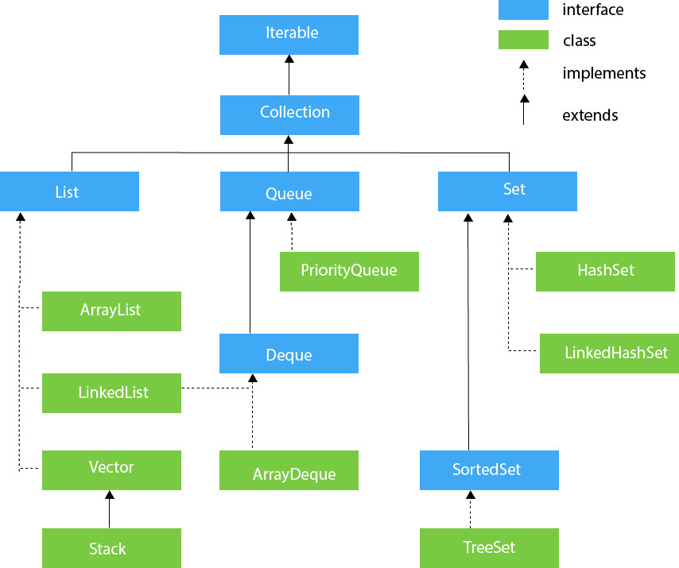

Figure 1: Collections in java Framework

Java Map Hierarchy

Figure 1: Map Interface in java